Social Media Bias

Project Overview:
This project seeks to help users recognise and address content bias in their social media feeds,
promoting exposure to diverse perspectives.

Data Description:
Data is sourced from users’ social media feeds, subject to the platform’s API and privacy constraints.
For instance, the YouTube API allows you to retrieve details on watch history, video descriptions,
and statistics (there are official APIs that we can to get youtube data). Instagram, on the other hand, is much stricter and may suspend your account if you
scrape without care. As a group, do your research and decide which social media site you wish to
work on — YouTube is used only as an example below.

For most official APIs, you will have to work with the OAuth2 protocol to gain permission to access a
user's history or feed.

Example persona:
Stan is a 45-year-old “uncle” who uses YouTube regularly to catch up on politics around the world.
He feels he is a sensible guy with a good perspective on world events. However, lately, he finds that
all he watches are news clips and shorts on all the mistakes Donald Trump is making. Yet, he cannot
avoid the nagging suspicion that he is missing something — how else did Trump get elected by the
majority of US citizens? He wonders if he is stuck in an echo chamber, unaware of alternative views
to his own.

Problem Statement:
Your task in this project is to help the user identify potential bias in their YouTube viewing habits.
Study their YouTube feed to understand the degree of bias in the videos that appear in their
recommendations or search results. From there, suggest videos or articles that present the same
story but with the opposite slant. Alternatively, explain why they might be in a bubble and what he
can do to get out of it. (idea: give suggestions of youtube searches they can make to get neutral content)

Audience:
The front-end team video should be directed at users of social media platforms seeking more
balanced content.
The back-end team video presentation should be targeted at data scientists who will be taking over
and continuing the work done.

Additional Information:
Tread carefully in this project — it’s an ethical minefield. First, users may not consent to having their
feeds scraped. An alternative is to set up dummy accounts and observe how quickly they descend
into a “rabbit hole.” Second, decide which types of bias you will examine — political (e.g.,
conservative vs liberal), ideological (e.g., pro-AI vs anti-AI), a tendency toward sensational stories,
“brainrot,” etc. Finally, consider how you will categorise content as biased or not; one approach is to
use the publishing channel as a proxy.

It would be instructive to read how others have approached this problem. Here are some articles to
guide you:
- Media Bias Monitor: Quantifying Biases of Social Media News Outlets at Large-Scale
https://www.pnas.org/doi/pdf/10.1073/pnas.2213020120
- Auditing YouTube’s recommendation system for ideologically congenial, extreme, and
problematic recommendations
- need to download from the file

CHATGPT summary of the media bias monitor paper:

What they asked
- Do YouTube recommendations (a) match users’ ideology (“congeniality”), (b) become more extreme the deeper you follow “Up-next”, and (c) lead to problematic channels?

How they tested it (methods)
- 100,000 trained “sock-puppet” browsers (not signed in) with five ideologies: very-left, left, center, right, very-right.
- Training: each puppet watched 100 ideologically labeled videos (30s each).
- Testing: collected (1) homepage recommendations and (2) Up-next trails (autoplay up to depth 20).
- Video ideology = audience-based slant: used tweets linking to a YouTube video; inferred slant from whether tweeters follow left/right political “landmarks.” Continuous scale −1 (very-left) to +1 (very-right), also binned into 5 categories.
- Problematic channels: matched to validated lists (e.g., “IDW,” “Alt-right,” “Conspiracy,” “QAnon,” etc.).

Key findings
- Congeniality is real, strongest on the homepage
  - Homepage top-1 is often ideologically aligned (e.g., ~58% congenial for very-left, ~65.5% for very-right).
  - Top-8 also congenial but slightly less so.
  - Right-leaning puppets get the most congenial recommendations; center puppets still see a rightward tilt.
- Up-next trails don’t strongly “radicalize” on ideology
  - For very-right, congenial exposure increases along the trail (≈ +37% by depth 20).
  - For very-left, congenial exposure is flat/slightly down.
  - Extremity shift is statistically significant but small: very-left mean slant −0.75 → −0.79, very-right +0.77 → +0.79 (on −1…+1).
- Problematic channels appear more as you go deeper
  - Share rises from ~1.2% at depth 1 to ~2.5% around depth 10, then tapers (likely undercount due to list coverage).
  - 36.1% of puppets encounter at least one problematic recommendation (up to ~40% for very-right).
  - Absolute volume is non-trivial despite low percentages.
- Asymmetry/right-ward tilt
  - Very-right users: strongest congeniality, only group with rising congeniality down the trail, and disproportionately more problematic channel exposure.
  - Heterogeneous and single-source (MSNBC/Fox) training still shows a right-leaning skew.

Limits they note
- Puppets always follow Up-next (real users may not).
- No measurement of user outcomes (beliefs/behavior).
- Not signed in; personalization via cookies only.
- Problematic lists are finite; deeper-trail channels may be uncatalogued (likely underestimates).

Practical takeaways for your bias-detection project
- Model ideology at the video level, not just channel level (use audience signals or text metadata + external labels).
- Track two spaces:
  - Homepage (strongest personalization/congeniality),
  - Up-next trail (look for drift in congeniality, extremity, and problematic exposure).
- Use their metrics:
  - Slant (−1…+1) and bins (very-left…very-right).
  - Congeniality slope (training vs. recommended slant).
  - Exposure E(d) = % of congenial (or problematic) videos at depth d relative to depth 0.
  - Cumulative incidence: % of users encountering ≥1 problematic rec by depth.
- Asymmetry checks: compare effects across user ideologies; watch for right-tilted exposure among centrists.
- Ethics/IRB: document non-human subjects design, cookie usage, and TOS compliance; avoid storing personal data.

One-paragraph gist
YouTube’s recommender does tailor political content to users’ prior ideology—especially on the homepage—and this congeniality is strongest for right-leaning users. Following Up-next does not meaningfully push people toward more ideologically extreme content on average, though very-left and very-right see small shifts. However, as users go deeper, the chance of encountering problematic channels (e.g., conspiratorial/extremist) increases—still a small share of all recommendations but reaching over a third of users at least once, and more for the very-right. Overall: expect congenial exposure, limited ideological radicalization, but growing contact with problematic channels as watch sessions continue, with a right-leaning asymmetry.

Decide tgt

- Which social media platform do we want to use and can we scrape data from it
- Youtube/Twitter/Reddit
- What kind of bias do we want to examine? eg political

- How we want to categorise whether content is biased (eg use publishing channel as a proxy)

Question
- What social media bias are we referring to - the platform side or is it user-centered?
  - We need to define what exactly bias is, and its source (e.g. some can be more platform based bias)
  - Scope down problem based on user interviews (to identify the problem) and create user personas
  - If we’re using user data from our interview (e.g. using their youtube history), we need to have a consent form
  - Stimulate user persona by creating dummy accounts on youtube (e.g. how long does it take to activate feedback loop if they watch a biased video)
- Open source API restrictions - read thru api documentation to make sure we don’t violate anything
- End product requirements
- eg. Dashboard to show bias metrics, can you analyse the content and say how much bias they are exposed to?
- Is it by channel? Political view?
- or Simulation a user going in to watch content, how fast does it enter an echochamber stage? After a certain threshold, you flag it as “too biased”
  - Intervening system also uty: recommendation system to reduce impact of bias? Or explicit warning that they are watching too skewed content
  - Design of web app: How does interface reduce exposure to bias?
- Front End: How do people choose what exactly to watch? There are other social nudges to allow people to behave a certain way. Not just the recommendation engine, also a design aspect that could nudge people to watch certain things
  - Eg. Likes, comments, views
  - To consider how user interface design influences social media/ user bias (e.g. wld u watch something with more likes or anything that shows up at the top of your fyp)
- Python packages
- Do literature review to see what others have done, then see which to implement/intuitive
- How to quantify bias? Different formulas and matrices
- Frontend -> Backend linkage (look thru end-to-end data science by Krish Naik, ref to project tips document)
  - Tell them how many models they need/what they need to be produces
  - Front end does analysis
  - Backend does model building + convert notebook to modular code to link components tgt (model injection, model transformation, model training)
  - Backend: build components for diff parts of the pipeline(e.g. data_ingestion.py, data_transformation.py, data_modelling.py) - can research industry standards
  - Can use different docker images as well for each component, or simplify to frontend & backend & database (2-3 should be enough)
  - Architecture/ pipeline example:
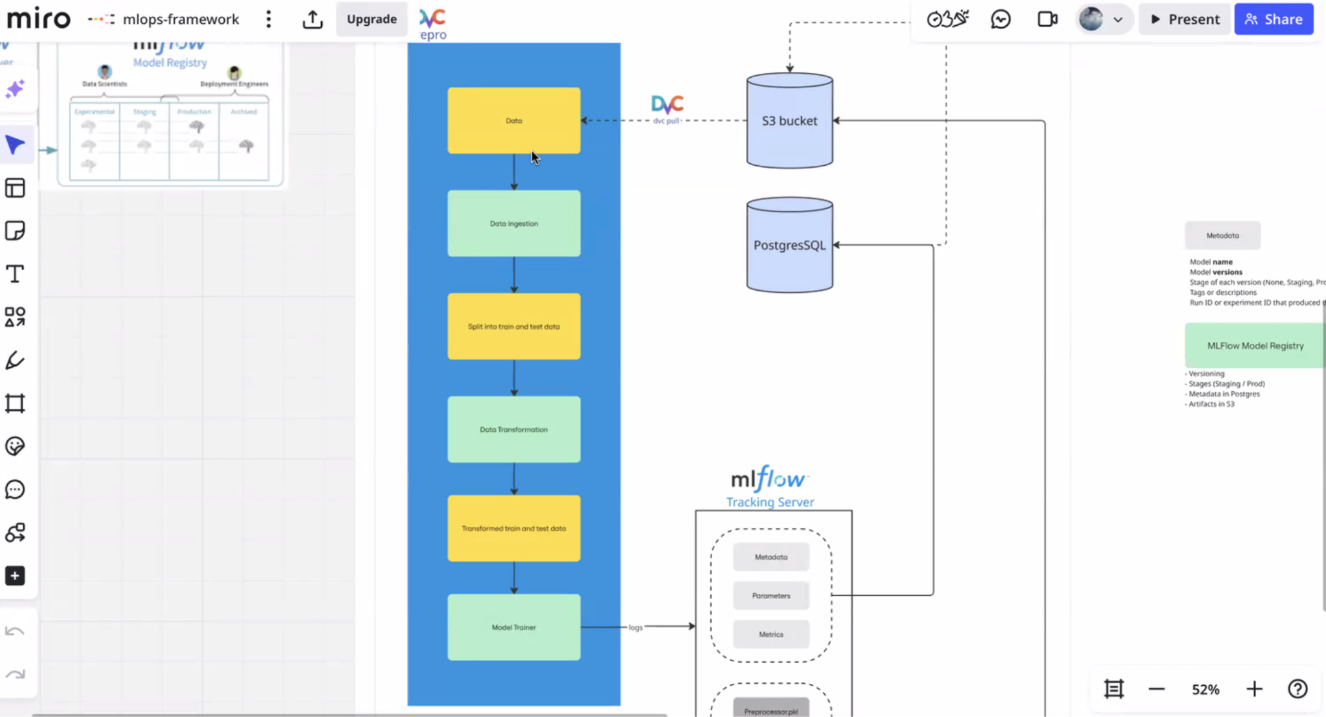
  - Docker → helpful for backend to display results to front end → with flask app, → front end design certain components of the web app (eg. pictures, videos, whatnot, can use template online, don’t need to design from scratch)
- have 3 containers minimally: frontend, backend, sql database
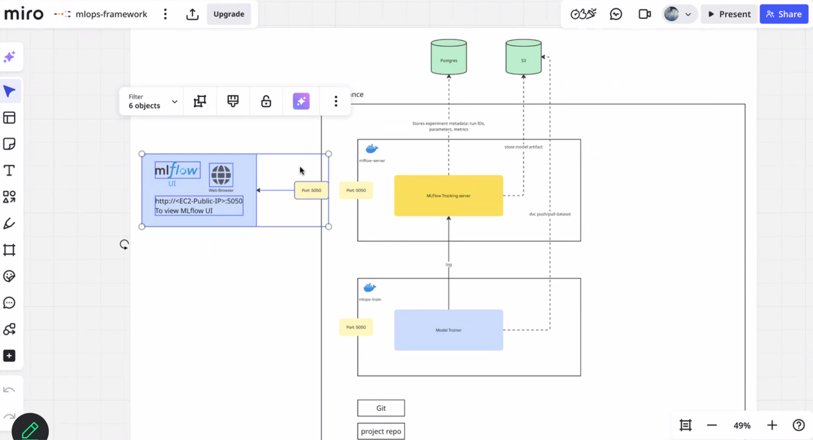
- One more time haha: What exactly is the backend providing for the frontend?
- flask app, api endpoints, then when you key in a value, then data is sent to backend for analysis, eg. can “GET” a piece of text from reddit and feed it into the backend model that has been built.
- Input data is sent into the backend, then the output is what is displayed to you on the website
- Similar to the api lecture learnt
- Eg. Get prerequisite or get graph that produces an output for you
- Project Tips doc by Sek Yi: End to End by Krish Naik

Addressing platform vs user’s bias:

Social Media Platform

[Subhashree]
Social Media Platform Suggestions:
- Youtube
  - ScrapeTube: dermasmid/scrapetube: A YouTube scraper for scraping channels, playlists, and searching 🔎
  - The above module allows us to get all YouTube videos either from a specific channel or a specific playlist → we can use this to narrow down to our particular social media bias and scrape related content (e.g. for politics can find a specific channel that shares differing views or a specific playlist that has a collation of recent political news)
  - There are many other modules like ScrapeTube on GitHub so we can just fork one from a public repo and try it out to see which one suits our data needs/ replicate the code on our own and tweak it
  - Pros: Rich long-form content in comments, video descriptions, and transcripts
  - Cons: Less restricted access than Twitter (based on no.of API request/calls made per day), video transcripts may not always be available or accurate, more complex content moderation may filter out some biased content
- X (Twitter)
  - Similar to YouTube, have different GitHub repos and existing work
  - Pros: High volume of real-time political opinions, shorter text format good for sentence-level bias detection.
  - Cons: Very limited access for free tier (based on no.of tweets scraped - might not be sufficient data if we’re training a model)
- Reddits
  - Similar to YouTube, have different GitHub repos and existing work
  - Pros: Free, generous API calls, rich discussion data, subreddit targeting - can easily find politically biased communities (r/politics, r/conservative, etc.)
  - Cons: Echo chamber effect - subreddits can be very homogeneous in viewpoint

Optional: Socialreaper library & data filtering methods
socialreaper is a Python 3.6+ library that scrapes Facebook, Twitter, Reddit, Youtube, Pinterest, and Tumblr data.
ScriptSmith/socialreaper: Social media scraping / data collection library for Facebook, Twitter, Reddit, YouTube, Pinterest, and Tumblr APIs
- This repo has a collection of different Social Medias that we can scrape data from, but mainly put it here to show the different ways we can filter and scrape the data we need
- E.g. Save the X number of most recent tweets from the user @Y to a csv file (can find a user/ official account that ‘specialises’ in the social media bias we are focusing on)

Getting data from social media platforms:
- Twikit (python library): Search for tweets without API key: https://github.com/d60/twikit
  - Can retrieve trending topics/potential bias using keywords
  - More info: https://twikit.readthedocs.io/en/latest/twikit.html
  - Pros: can fetch large number of tweets
  - Cons: might not fully comply with API rules
Note: Twitter also uses lots of hashtags, which can help with bias analysis
- YARS (python library): scrap reddit for posts, comments, user data, etc: https://github.com/datavorous/yars
  - Pros: It works for multiple subreddits in a single run
  - Can collect posts, comments, upvotes etc
  - Cons: Less stable for large datasets
  - Might not fully comply with API rules
- YouTubeScrapper:
  - Scrap youtube video description, likes, comments + extract data from videos: https://github.com/palahsu/YouTubeScraper
  - Need to set up, get Api key from https://console.cloud.google.com/, input into setup.py
  - Pros: fully legal and safe
  - Can get descriptions, likes, comments, replies etc
  - Cons: limits requests per day per 100s

Choosing Social Media Platform

Platform | Data Access (API/Scraping) | Relevance to Bias/Echo Chambers | Ethical/Legal Risk | Technical Difficulty | Pros | Cons
YouTube | ✅ Official API (OAuth2), Google Takeout, dummy accounts | ⭐⭐⭐⭐ Strong recommender-driven bias, political rabbit holes | Medium (scraping history risky, but API OK with consent) | Medium (need OAuth + NLP on video metadata) | Rich metadata (titles, tags, transcripts), clear bias cases, strong echo chamber relevance | Watch history access limited, labeling bias requires external datasets
Reddit | ✅ PRAW API (easy, free), Pushshift archives | ⭐⭐⭐ Subreddit communities are natural echo chambers | Low | Low (well-documented Python libs) | Easy to scrape, text-rich, network-based bias analysis possible | Less about recommender engine, bias comes from self-selection
TikTok | ❌ Limited API, scraping risky | ⭐⭐⭐⭐ Algorithm is highly personalized & addictive, strong bias relevance | High (ToS violations, detection likely) | High (video-based analysis, need custom scraper) | Extremely relevant to bias/rabbit hole research, relatable | Very hard to scrape ethically, annotation & stance detection challenging
Twitter (X) | ⚠️ API paywalled, snscrape (unofficial) | ⭐⭐⭐⭐ Highly political, strong polarization signals | Medium–High (scraping violates ToS) | Medium (text analysis easy, but access is main blocker) | Rich political text data, hashtags useful for stance detection | Free API access restricted, may be infeasible
Instagram / Facebook | ❌ Very restricted APIs (ads/business only), scraping risky | ⭐ Bias is present but less transparent | High (account bans, privacy concerns) | High | Very popular, relatable for users | Nearly impossible to get personalized feed data without risk

Recommendation for the project:
- Primary Platform: YouTube → best balance of bias relevance + feasible data access.
- Secondary Option (for comparison): Reddit → easy to implement, complements YouTube with text-based echo chamber analysis.
- Avoid: TikTok (too hard), Twitter (API restrictions), Instagram/Facebook (too locked down).

Project Roadmap: Detecting & Addressing Social Media Bias

1. Data Collection

🔹 YouTube (Primary)
- Access Method:
  - Official YouTube Data API (v3) with OAuth2 (requires user consent).
  - Dummy accounts → simulate different viewing habits (e.g., “politics uncle Stan,” “sports fan,” etc.).
- Data Available:
  - Video title, description, channel metadata
  - Statistics (views, likes, comments)
  - Transcripts (auto-captions for NLP)
  - Recommendation chains (by clicking “Up Next” repeatedly)

🔹 Reddit (Secondary)
- Access Method:
  - PRAW API (free + simple with Python).
  - Optional: Pushshift.io archive (historical Reddit data).
- Data Available:
  - Subreddit membership and posts
  - Upvotes/downvotes (popularity signals)
  - Comment text for stance detection
  - Cross-post patterns → detect echo chambers

2. Preprocessing & Bias Detection
- Text Cleaning: remove stopwords, lemmatization, etc.
- Bias Categories (decide scope):
  - Political (e.g., conservative vs liberal)
  - Sensationalism / clickbait
  - Ideological stances (e.g., pro/anti AI, climate change)
- Classification Approaches:
  - Channel/Source as proxy (e.g., CNN vs Fox, r/politics vs r/Conservative).
  - Sentiment/Stance analysis (using pretrained NLP models like VADER, DistilBERT).
  - Content diversity metrics: % of unique perspectives in feed.

3. Feed Bias Quantification
- Metrics to Compute:
  - Source concentration → % of videos/posts from top N sources.
  - Polarity score → how left/right-leaning or positive/negative the feed is.
  - Entropy / diversity index → measure of how balanced the content sources are.
  - Network clustering (for Reddit) → detect echo chamber strength.

4. Echo Chamber & Rabbit Hole Analysis
- YouTube:
  - Follow recommendation chains → see if content becomes more extreme over clicks.
  - Track “topic drift” (e.g., neutral news → partisan hot takes).
- Reddit:
  - Map subreddit co-posting → detect isolated vs diverse communities.
  - Check if users are exposed to only one “side” of the debate.

5. Bias Mitigation & Counter-Suggestions
- Approach 1: Suggest “opposite slant” content.
  - Example: If user watches pro-Trump clips → recommend balanced/critical sources, and vice versa.
- Approach 2: Show diversity dashboards.
  - Visualization of “here’s how skewed your feed is, here’s what you’re missing.”
- Approach 3: Encourage exploration.
  - Suggest neutral/credible sources to break the bubble.

6. Outputs
- Frontend video (for users):
  - Simple visual dashboard: “Your feed is X% left-leaning, 80% from just 3 sources → here are counterpoints.”
  - Educational tone: how to escape echo chambers.
- Backend video (for data scientists):
  - Walkthrough of API use, bias detection pipeline, metrics.
  - Clear documentation for future teams to extend work.

Summary Roadmap
- Pick YouTube (main) + Reddit (backup/comparison).
- Collect data (API, Takeout, dummy accounts).
- Preprocess + classify bias (channel proxies + NLP).
- Quantify bias (source concentration, polarity, diversity index).
- Analyze echo chambers (rec-chains, subreddit networks).
- Suggest counter-content & build dashboards.
- Deliver user-facing demo + data-science documentation.

Biases
- Topic Distribution Bias – when a user’s recommended feed is overly dominated by certain topics as compared to a balanced distribution
  - How to measure?
    - Defining topics – categories provided by the YouTube API
      - Creator chooses which topic their video is
    - Collecting Data (API / dummy accounts)
      - Each video can be tagged with one topic or multiple (if multiple, then count +1 to each of the topics it was tagged to)
    - Compute the Distribution
      - Compute the total number of videos that fall into each category and convert it to percentages
      - Create Dummy Accounts and each one will be on a different topic, and each account will watch a certain number of videos to train it in that specific topic. To test this, collect watch history and homepage recommendations
- Political Ideology Bias → User’s feed has content leading towards a political stance (more common and measurable, with clear opposite slant recommendations)
  - Dashboard can have bias score + pie chart showing slant distribution
  - Time series: area chart showing percent left/center/right by week/month
- Brand Bias – User’s feed has content of the same brand (e.g. Samsung)
Categorising videos:
- Channel-based → Official Company channels will surely give positive reviews of their products
- Keyword-based → Scan the titles, descriptions and tags of videos to detect brand biased content and scan tone using sentimental analysis to determine if positive or negative review
- Content-based (transcripts) → Not via official API

Ways to tag/classify a video to detect its bias
- Video title
- Description
- Tags added by creator to help algorithm
  - Con: Tagging may not be consistent, and some videos might not even have tags
- Evaluation of transcripts of videos

Measuring bias in feed and solution
Measuring the Bias
- Bias = Percentage(topic in watch history) − Percentage(topic in feed)
- Over-representation ratio → Percentage(topic in feed) ÷ Percentage(topic in watch history)
- Computing entropy for feed and watch history → calculated by using scipy.stats.entropy
How to show bias to users?
- Bar chart showing bias per topic
  - Positive = overrepresented in recommendations
  - Negative = underrepresented
- Over-representation Heat Map to highlight topics that are 2× or 3× more represented in recommendations as compared to watch history

Suggesting opposite slant
- Show the user their current biased feed and show a balanced suggestion panel (this also helps them get out of the “bubble”)
  - Example: if videos in the politics category are left-leaning, then suggest videos on right-leaning politics

YouTube API information

1. Video Information
- Video ID & URL
- Title
- Description
- Tags (if set by uploader)
- Category ID (maps to categories like News & Politics, Entertainment, etc.)
- Channel ID / Channel title
- Published date
- Statistics: view count, like count, comment count
- Duration (e.g., 12 minutes 30 seconds)
- Thumbnail URLs

2. Channel Information
- Channel title
- Description
- Country (if provided)
- Statistics: subscriber count, total views, total videos
- Channel category / type

3. User Data (requires OAuth2 login) - if we wna test on irl user. if not j use dummy acct
If the user logs in and grants permission, using the API, you can fetch:
- Watch history (limited – only if user authorizes YouTube History scope)
- Liked videos
- Subscriptions (which channels they follow)
- Playlists (created or saved by the user)
⚠️ Limitation: The API does not give you the homepage recommendation feed. That’s private to YouTube’s algorithm. To approximate it, people use related videos API or dummy accounts

Questions
- API vs dummy accounts or both? if use dummy accounts, can actually have their history
- Scope? if for example use brand bias, do we use
- brand bias in specific products like phones
- specific brands like apple vs samsung
- overall brand bias where once someone watches content of a brand, they keep seeing that brand sponsored videos or reviews of that brand’s products?
- After detecting bias, are we going to suggest content of opposite slant or tell them how to get out of the bubble?
- if suggesting opposite slant, we need to be able to match content of same story but opposite slant which sounds complex because not all content might be easy to match.

